WSU E-Forms Request for Shipment of Merchandise
Log into E-Forms- http://public.wsu.edu/~forms/eforms.html

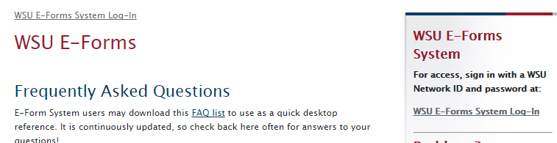

Select 'Request for Shipment of Merchandise' from the Form Templates

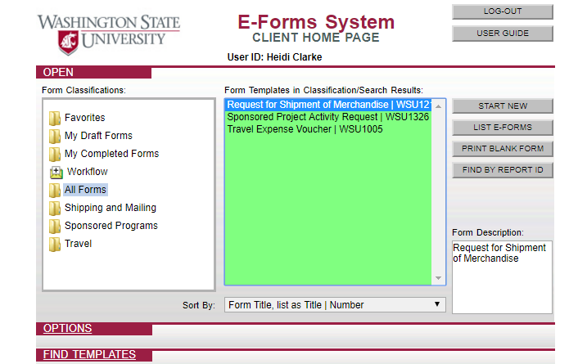
Select 'Start New'

Fill out the highlighted boxes with the information required
Be sure you complete the sections on 'Ship Via', 'Billing', & 'Hazardous Materials'

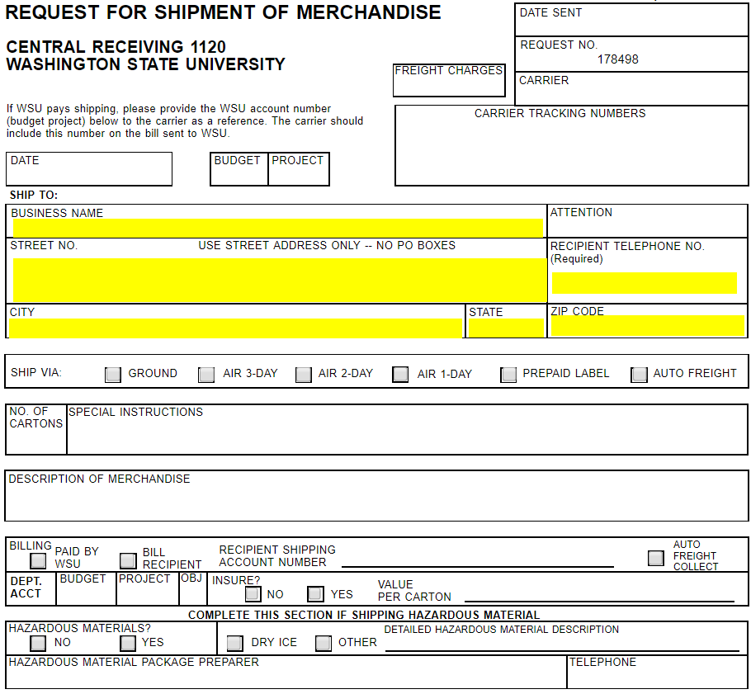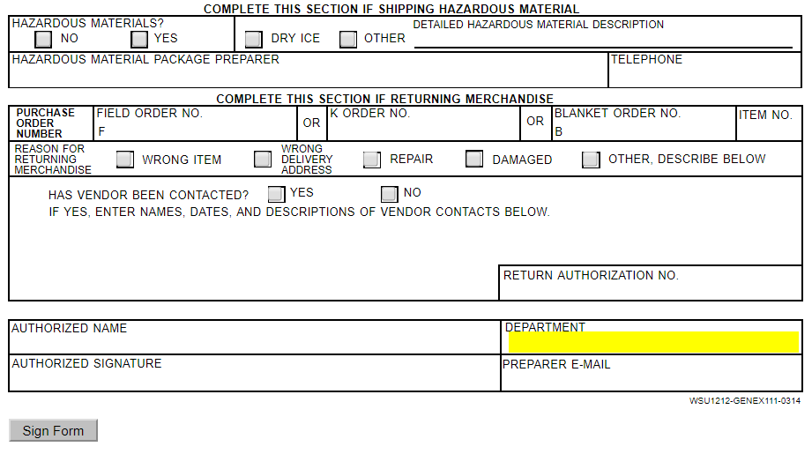
Click 'Sign Form' when information is complete
Click 'Submit to Workflow' at the bottom of page
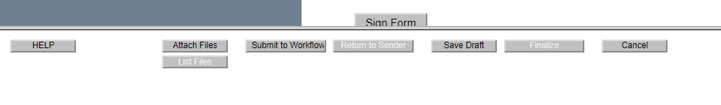
On the left hand side of your screen, select 'Central Receiving' and 'ADD'

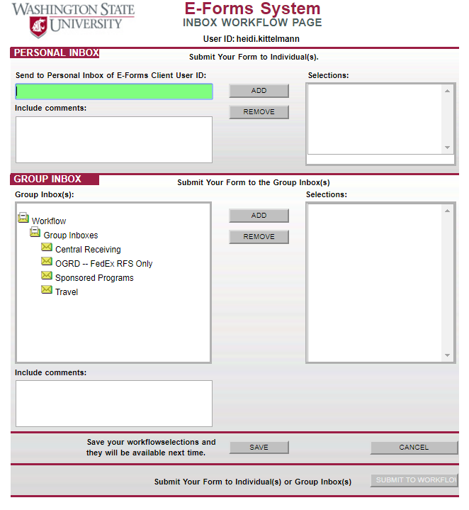
Select 'Submit to Workflow' at the bottom of the screen.
Write request # on the box. Print out a copy of the form and place with the box in room 285.

Call Central Receiving 5-5575 and let them know there is a package to pick up in Johnson Hall 285 and if they need a hand truck.

